Submitted To: Sir Suleman Amin

Name: Muhammad Shaheer

Subject: Micro Economics

Roll no: 20p-0480

Assignment 2

NATIONAL UNIVERSTIY OF COMPUTER AND EMERGING SCIENCES, FAST- PESHAWAR CAMPUS

# Question no 1

# Law of Supply:

The law of supply is a micro economic law. It states that, all other factors being equal, as the price of a good or service increases, the quantity of that good or service that suppliers offer will increase, and vice versa.

In plain terms, this law means that as the price of an item goes up, suppliers will attempt to maximize their profits by increasing the number of that item that they sell.

# Some Points:

* The law of supply says that a higher price will lead producers to supply a higher quantity to the market.
* Because businesses seek to increase revenue, when they expect to receive a higher price for something, they will produce more of it.
* Meanwhile, if prices fall, suppliers are disincentivized from producing as much.
* Supply in a market can be depicted as an upward-sloping supply curve that shows how the quantity supplied will respond to various prices over a period of time.

# Explanation:

The chart below depicts the law of supply using a supply curve, which is upward sloping. A, B, and C are points on the supply curve. Each point on the curve reflects a direct correlation between quantity supplied (Q) and price (P). So, at point A, the quantity supplied will be Q1 and the price will be P1, and so on.

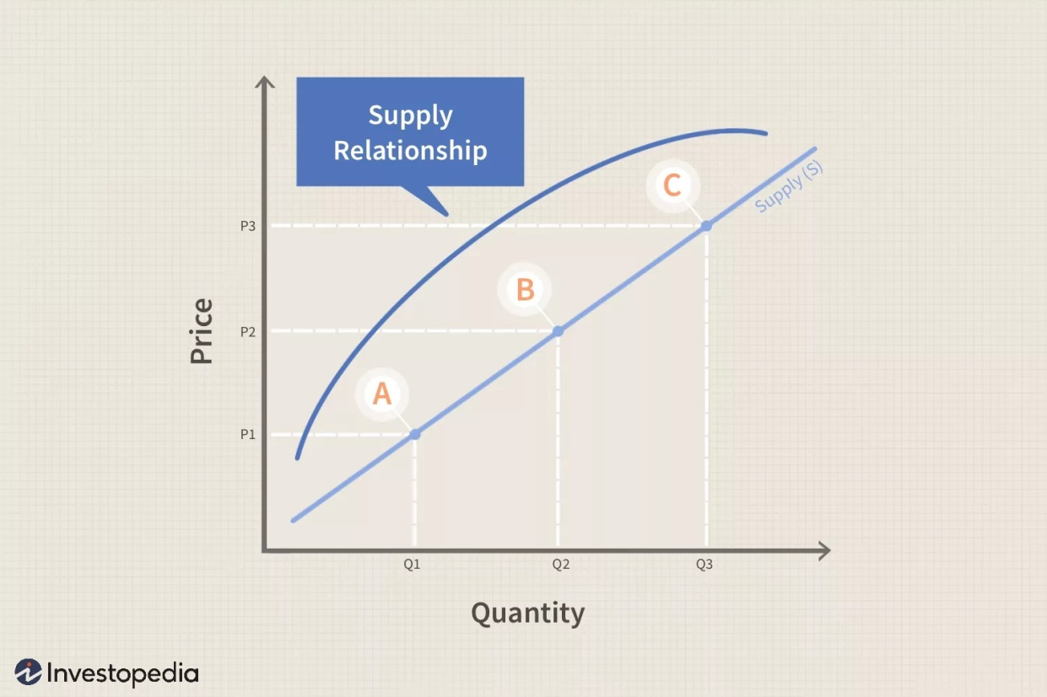

The supply curve is upward sloping because, over time, suppliers can choose how much of their goods to produce and later bring to market. At any given point in time, however, the supply that sellers bring to market is fixed, and sellers simply face a decision to either sell or withhold their stock from a sale; consumer demand sets the price, and sellers can only charge what the market will bear.

If consumer demand rises over time, the price will rise, and suppliers can choose to devote new resources to production (or new suppliers can enter the market), which increases the quantity supplied. Demand ultimately sets the price in a competitive market; supplier response to the price they can expect to receive sets the quantity supplied.

The law of supply is one of the most fundamental concepts in economics. It works with the law of demand to explain how market economies allocate resources and determine the prices of goods and services.

# Examples:

The law of supply summarizes the effect price changes have on producer behavior. For example, a business will make more video game systems if the price of those systems increases. The opposite is true if the price of video game systems decreases. The company might supply 1 million systems if the price is $200 each, but if the price increases to $300, they might supply 1.5 million systems.

To further illustrate this concept, consider how gas prices work. When the price of gasoline rises, it encourages profit-seeking firms to take actions to expand supply, such as:

* Increase exploration for oil reserves.
* Drill for more oil.
* Invest in more pipelines and tankers to bring the oil to plants where it can be refined into gasoline.
* Build new oil refineries.
* Purchase additional pipelines and trucks to ship the gasoline to gas stations.
* Open more gas stations.
* Keep existing gas stations open longer hours.

# Assumptions:

Some Assumptions are:

* The price of other commodities is constant.
* The state of technology has not changed.
* The price of factors of production is constant.
* The taxation laws remain the same.
* The producer’s objectives are constant.

The Law of Supply can be better understood with the help of the following table and graph.

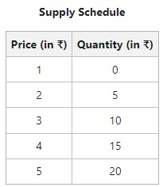

The above table indicates that when the price of the commodity rises, an increasing number of units are offered for sale.

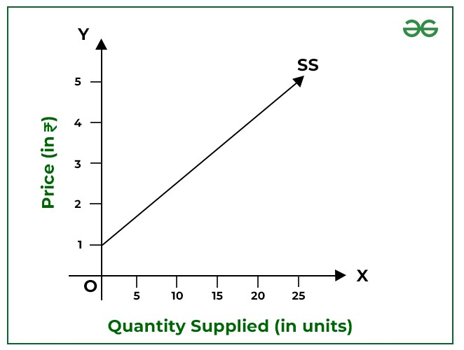

# Limitations:

**Future Prices:**

 When the p price rises and the seller expects the future price to rise further, supply will decline as the seller will be induced to withhold supplies so as to sell later and earn larger profits then.

**Agricultural Output:**

 Law of supply may not applies in case of agricultural commodities as their production cannot be increased at once following price increase.

**Subsistence Farmers:**

 In underdeveloped countries where agriculture is characterized with subsistence farmers, law of supply may not apply.

**Factors other than Price not Remaining Constant:**

 The law of supply is stated on the assumption that factors other than the price of the commodity remain constant.

# Extension and Contraction of Supply:

**Extension of Supply:**

This occurs when the quantity supplied of a good or service increases in response to a rise in its price, while all other factors remain constant. For example, if the price of oranges increases, orange farmers may produce more oranges to take advantage of the higher profitability.

**Contraction of Supply:**

On the other hand, contraction of supply happens when the quantity supplied decreases due to a decrease in price, holding other factors constant. For instance, if the price of oil decreases significantly, some oil-producing companies might reduce their output to avoid losses.

# Shift of Supply Curve:

The supply curve represents the relationship between price and quantity supplied, assuming all other factors remain constant. When factors other than price change, the entire supply curve shifts.

Factors causing a shift in the supply curve include changes in input prices, technology, government regulations, weather conditions, and expectations of future prices.

For example, advancements in technology might lead to lower production costs for a product, shifting the supply curve to the right, indicating an increase in supply at all price levels. Conversely, adverse weather conditions affecting crop yields might shift the supply curve to the left, indicating a decrease in supply at all price levels.